Title: Introduction to QGIS

What you will learn:
- The basic layout of QGIS and how to add data.
- Common GIS file formats
- Preparing a printable map

Resources:
- Data:
- Laboratory module
- Video:

Laboratory Exercise:
In this exercise, you will explore and manage geospatial data using the Browser panel of QGIS. This exercise will also introduce you to the QGIS interface. It is important to learn the concepts in this exercise as future exercises will require the skills covered here.

In this exercise, you will add maps (we call layers) to the project and explore their properties. You will also explore the data attached to these maps through the attribute tables.

Deliverables:
- Laboratory report – this should contain the answers to questions, a screenshot of the map, and the image of the final map in addition to what is required in the template.
- Answers to the questions (Part 1 step 9)
- One screenshot of the map view as described in the procedure (step 7)
- Final map inserted in the laboratory report and submitted as a PDF file

Procedure:

Part 1 – Adding Maps and exploring their properties

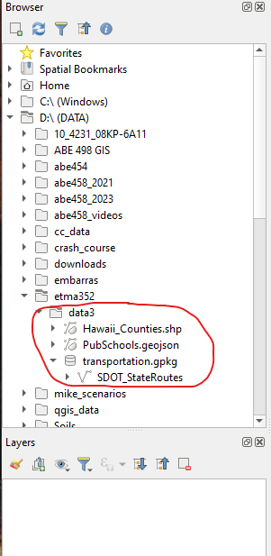
1. Download the data folder data3 from Canvas and save it on your computer. Organizing your workspace is the first step in working on a project with geospatial datasets. It is important that you organize the datasets logically on the computer and make them easy to find. Before starting the exercise, UNZIP the data folder. DO NOT attempt to open, rearrange, or move the files inside the folder.
Figure 1. Lab3 data in Browser Panel

2. Open QGIS.

3. There are many ways to open or add a file on QGIS. For this exercise, we will focus on the BROWSER panel which displays the file tree. Go to where you saved the unzipped data folder “lab3” and expand the folder to see the files inside (Figure 1). You will see three files in the folder with different icons. The vector file icon indicates that the dataset is a vector layer while the icon indicates that the dataset is a database.

4. Now that you are familiar with the basic layout of the browser panel, you will explore some geospatial data, learn how to access the properties of the layer, and begin adding the data to QGIS. Right-click on Hawaii_Counties.shp layer and then Layer Properties. The layer properties window shows some basic information about the dataset. You will notice that the storage type is ESRI shapefile, the geometry type is a polygon and it has 9 features (Figure 2). The Coordinate Reference System (CRS) of the layer is set at EPSG:26904 – NAD83/UTM 4N.

Clicking the “Preview” tab will show you the spatial features of the layer and the “Attributes” tab the attribute table which contains information about the polygons in the layer. In the case of Hawaii_Counties, it shows the names of the counties and the corresponding islands.
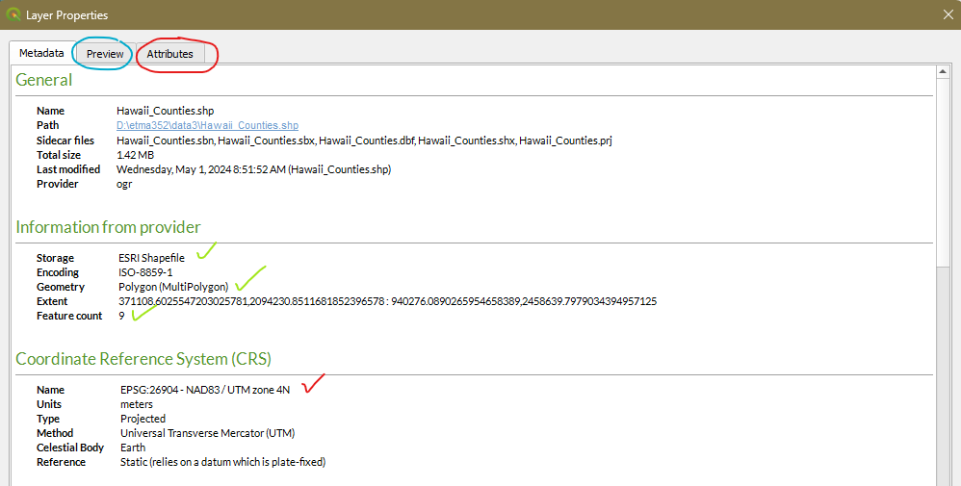
Figure 2. Layer Properties

There are many file formats used in GIS. For this exercise, we will use:
- Shapefile (.shp) – A GIS file format for vector data
- GeoJSON (.geojson) – an open standard format that stores spatial data as JavaScript (http://geojson.org/)
- Geodatabases (e.g., gpkg) – relational databases capable of storing GIS data layers in either vector or raster formats.

5. “Hawaii_Counties.shp” is a shapefile. Shapefiles are the most common vector file format. As previously learned, a shapefile file can have one geometry type: a polygon, line, or point but, it is a collection of files on the computer with a common name with different extensions. Right-click on Hawaii_Counties.shp layer then Show in Files. You will see the different files that make up “Hawaii_Counties.shp”. They have the same names but with different extensions. There are three files that are mandatory to have a functioning shapefile:
- .shp – stores the feature geometry
- .shx – an index linking the .shp to the .dbf
- .dbf – a database file which stores the attributes

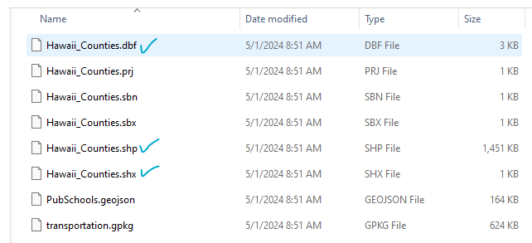
Figure 3. Complete list of files that come with the shapefile

6. To open a file in QGIS, you can right-click on the file and then “Add Layer to Project”, or simply double-click on the file. Open “Hawaii_Counties.shp”. The map will appear on the map view and the layer in the “Layers” panel (Figure x)
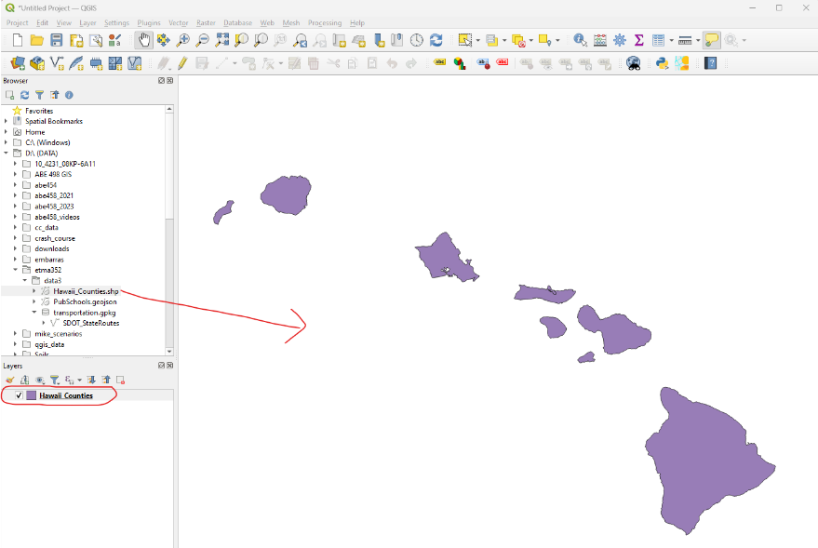
Figure 4. First layer in QGIS

7. Now switch your attention to the “Layers panel” and right-click on the Hawaii_Counties layer (encircled in Figure x) and then Show Labels. You can now see the names of the islands on the map. Right-click on the Hawaii_Counties layer again and then Open Attribute Table. Move the table around and adjust its size to not cover the map. Take a screenshot of your computer screen or use the snipping tool to capture the map with the attribute table being displayed (Figure y). Insert the image in your lab report. The attribute table contains the attributes of the layer. Each row corresponds to one polygon. If you recall from exploring this dataset (step 4), the layer has 9 features. The attribute table has 9 corresponding records. The columns are things we know about the polygon.
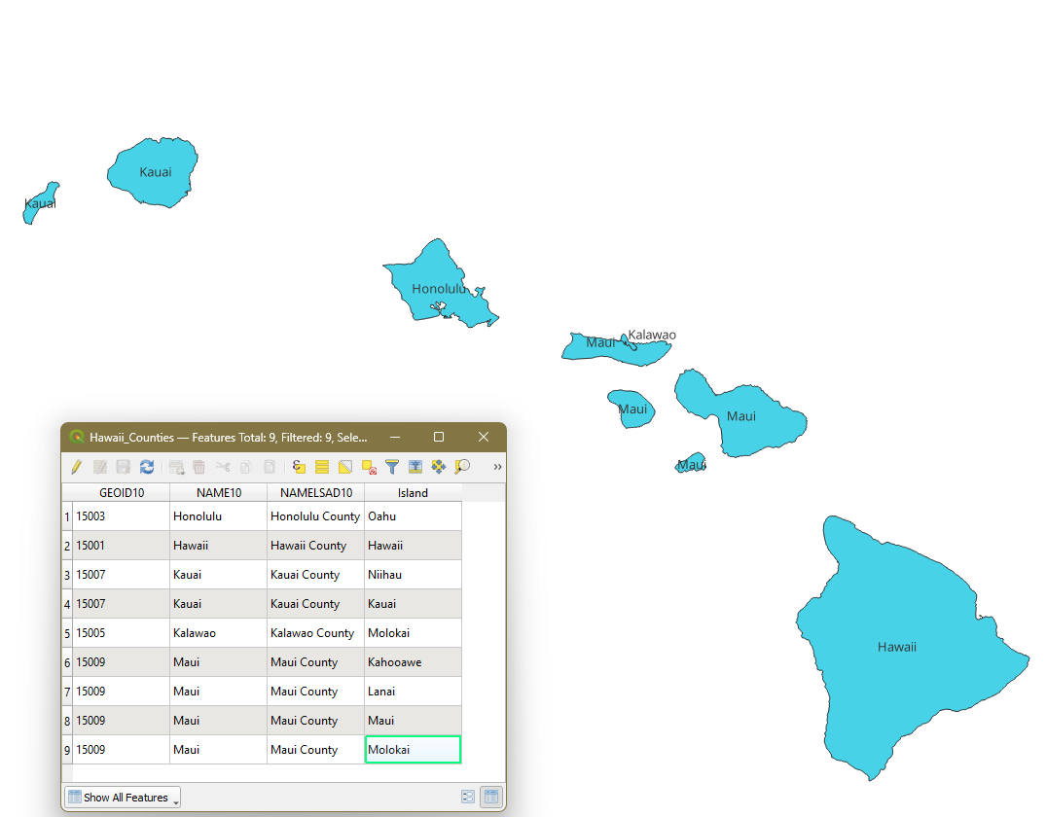
Figure 5. Attribute table of layer

8. Next, add PubSchools.geojson by double-clicking the file. Expand transportation.gpkg and add SDOT_StateRoutes. You now have three layers in the map view. On the “Layer” panel you can uncheck (and check) the layers in the Layers panel to make them disappear (and appear) on the map view. You can change the order of the maps by dragging the layers up or down. The final order of the maps should show the public schools and routes in front of the counties.

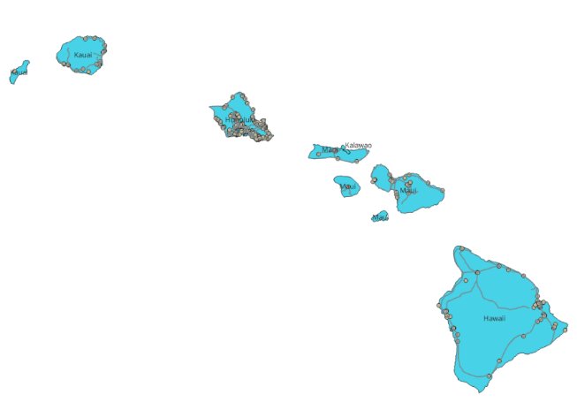
Figure 6. Three layers loaded in map canvas.

9. Explore PubSchools.geojson and SDOT_StateRoutes and answer the following questions:
- What is the geometry of each layer?
- How many features are there in each layer?
- What is the CRS of each layer?
- What information is included in each layer (from the attribute table)?

Part 2 – Compose a map deliverable.

You will now create a printable map which you submit with your laboratory report. You will follow the same procedure below when asked to create a printable map in your next laboratory exercises.

1. Open the New Print Layout. From the menu bar choose Project – New Print Layout, or click the New Print Layout 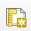 button from the tool bar.

2. Name the Layout “My First Map”

3. Click OK. A new Print Layout will open. This is where you craft your map.

The Print Layout is an application with many tools that allow you to craft a map. The main window of Print Layout displays a piece of paper upon which the map will be designed (see Figure 7). To the left are buttons for adding elements to your map like texts, legend, scale bar, and images. The right side will show the current item you are working on. This is where you edit the properties of the item.

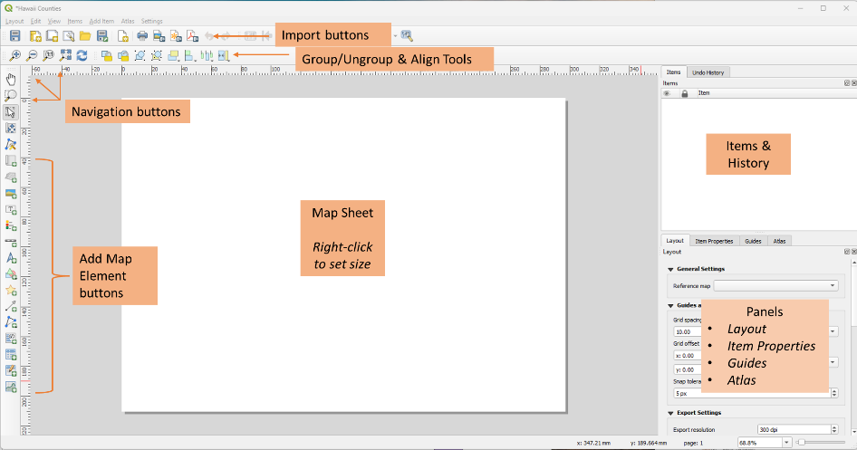
Figure 7. The Print Layout Window

4. Set the paper size by right-clicking on the black page (map sheet) then choose Page Properties. Change the following.
- Size = Letter
- Orientation = Landscape

5. Click the Add Map button (part of “add map buttons”, see Figure 7), hover the mouse on the map sheet, and with the mouse turning to a cross, hold the left mouse and draw a box to where you would like the map to go. Remember that you will need room for a title and a legend on the map. The map object can be resized and moved once added by clicking the Select/Move 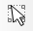button. NOTE: This is the usual procedure for adding elements to your map.

6. With the map selected, right-click on the map and choose Item Properties. This will open the Item Properties window on the right side of the map sheet. There are buttons across the top of the panel to control the map extent. Click the Set Map Extent to Match Main Canvas Extent button. This orients the map on the sheet of paper as it appears on QGIS.

7. Add the title: Click the Add Label tool and draw a box on the map sheet where you want the title of the map to be. On the Item Properties panel, the Label window will open. Type the title of the map as “My First Map” (Figure 8). Click the Font dropdown arrow then choose Configure Format (Figure 8) and change the following:
- Font = Arial
- Style = Bold
- Size = 30

8. Go back to Label window by clicking the back button (top of window)

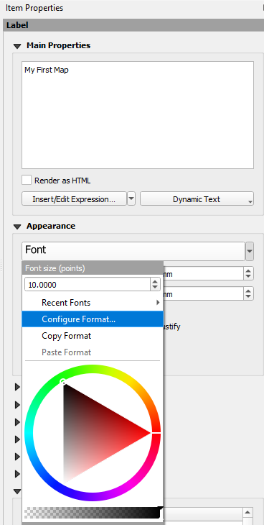
Figure 8. Editing Label (or text) Properties

9. On the Label window, set the horizontal and vertical alignments to “center” and “middle”, respectively.

10. Add the legend: Click the Add Legend button and draw a box where you want the legend to be. Right-click on the legend and choose Item Properties (if the Item Properties window is not open). Type the Title as “Legend”. On the Legend Items, uncheck the Auto update box (Figure 9).
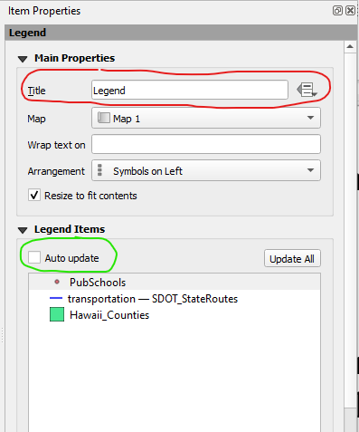
Figure 9. Editing Legend Properties

11. Double click on PubSchools. This will open a Label window where you can edit the name of the layer (Figure 10). Change the name to “Public Schools” and click the back button to go back to the Legend Item Properties window (Figure 10).

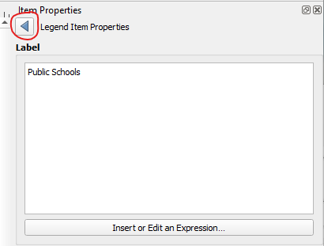
Figure 10. Editing the Labels of Legend Items

12. Change the names of the two remaining layers following step 11 as follows:
- Transportation-SDOT_StateRoutes to Public Transportation Routes
- Hawaii_Counties to Hawaii Counties

13. Add your name: Using the steps for adding the title, add your name and date to the map. Edit the font: Font = Arial; Size = 20

14. Add more items to your map:
- North Arrow by clicking
- Scale bar by clicking

Your map should look something like in Figure 11 but with different colors. The placement of the title, legend, north arrow, scale bar, and your name may also be different.

15. Export your map as an image using the export button . Use *.PNG as file type and Export resolution = 300 dpi. This is the file that you will insert in your lab report.

16. Export your map as a pdf using the export button 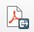. Uncheck “Always export as vectors” and “Append georeferenced information” options then “save”. This is the file that you will upload on Canvas together with your lab report.

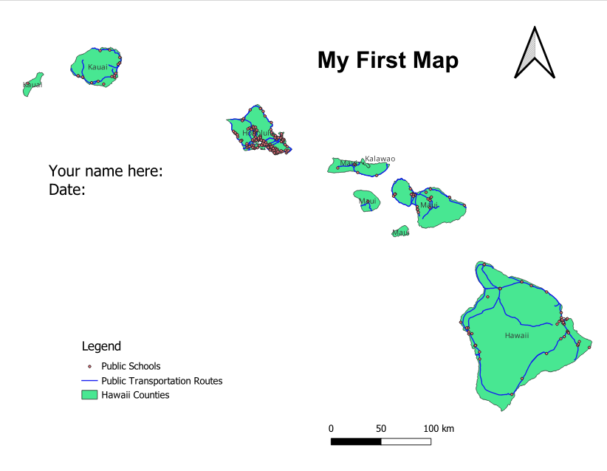
Figure 11. The Final Map

